NCT’s Jaehyun Design A T-Shirt and Fans’s Reaction Have Been Hilarious
Would you wear this?

Artikel ini telah tayang di Koreaboo, NCT’s Jaehyun Design A T-Shirt and Fans’s Reaction Have Been Hilarious Would you wear this?, https://www.koreaboo.com/stories/nct-jaehyun-designed-tshirt-fans-reactions-hilarious/

NCT 127 recently design t-shirt in collaboration with streetwear brand Slow acid. Their t-shirt are personally design by each memberm. However, member Jaehyun’s design has gotten some mixed responses with its straightforward approach. While others drew cute animals or symbols on their shirts, Jaehyun went all out and wrote whatever represented him on his shirt.
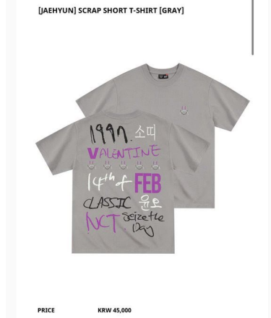
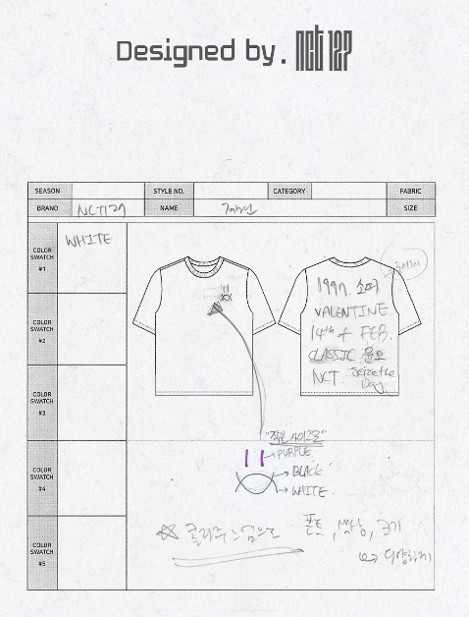

Personally naming it the “Scarp Short T-Shirt”, Jaehyun wrote on the shirt a variety of things that represented him, including the following
- 1997, his birth year
- Valentine, his birthday, which falls on February 14
- Cow zodiac sign
- Classic a word he feels represents him
- His motto, “Seize the day”.
- His birth name, Yoonoh
- NCT, his group
However, fans have found his t-shirt hilarious, given that it might be a little odd to wear all of that in public. Here are some of the funniest reation.
“The way cow zodiac sign is written there so blatantly and straightly, is so funny. Jung Jaeyun may have designed this but he wouldn’t wear it out”
“Jaehyun now the entire world will know your zodiac is the cow”
“I can,t wear this out event if you pay me to”
“if you wear Jung Jaehyun’s t-shirt out, people will able to know you’re fan of jahyun from 500 m away. For real this is just proof that the person that is wearing it is a NCTzen”
What do you think? Would you wear it?

