LAMPIRAN
Lampiran A

I. Instrumen Penelitian Setelah Divalidasi oleh Experts

Variabel, Indikator, dan Butir Pernyataan Instrumen untuk Uji Validitas dan Reliabilitas Instrumen

Variable Penelitian | Indikator Variabel | Butir Pernyataan
1. Kepemimpinan Guru | A. Characteristic | 1 | My teacher shares positive values with her students.
1. Kepemimpinan Guru | A. Characteristic | 2* | My teacher has a loud and clear voice.
1. Kepemimpinan Guru | A. Characteristic | 3 | My teacher is clear in giving instructions.
1. Kepemimpinan Guru | A. Characteristic | 4* | My teacher is fair to her students.
1. Kepemimpinan Guru | A. Characteristic | 5 | My teacher is a role model to her students.
1. Kepemimpinan Guru | B. Influence | 6* | My teacher makes it interesting to learn this topic.
1. Kepemimpinan Guru | B. Influence | 7* | My teacher encourages students to participate in group work.
1. Kepemimpinan Guru | B. Influence | 8* | My teacher has established discipline well.
1. Kepemimpinan Guru | B. Influence | 9* | My teacher pushes us to give our best.
1. Kepemimpinan Guru | B. Influence | 10* | My teacher promotes collaboration in learning.
1. Kepemimpinan Guru | C. Knowledge | 11* | My teacher is able to answer questions well.
1. Kepemimpinan Guru | C. Knowledge | 12 | My teacher uses technology well in teaching.
1. Kepemimpinan Guru | C. Knowledge | 13 | My teacher uses a variety of teaching techniques.
1. Kepemimpinan Guru | C. Knowledge | 14 | My teacher can relate the topic to real-life applications.
1. Kepemimpinan Guru | C. Knowledge | 15* | My teacher is confident in teaching.

2. Motivasi Siswa | A. Intrinsic Value | 16* | I enjoy learning even though there is no reward.
2. Motivasi Siswa | A. Intrinsic Value | 17* | I prefer classwork that is more challenging.
2. Motivasi Siswa | A. Intrinsic Value | 18* | I want to excel in this subject, even though no one asks me to.
2. Motivasi Siswa | A. Intrinsic Value | 19* | Even when I did poorly on a test, I try to learn from my mistakes.
2. Motivasi Siswa | B. Extrinsic Value | 20* | Getting a good grade in this class is satisfying.
2. Motivasi Siswa | B. Extrinsic Value | 21 | It is important for me to improve my overall score.
2. Motivasi Siswa | B. Extrinsic Value | 22* | I am more motivated when I am praised for getting a good grade.
2. Motivasi Siswa | B. Extrinsic Value | 23* | I want to do well in this class to show my ability to others.
2. Motivasi Siswa | C. Task Value | 24* | I like the topic I am learning right now.
2. Motivasi Siswa | C. Task Value | 25 | It is important for me to learn what is being taught.
2. Motivasi Siswa | C. Task Value | 26 | It is useful for me to learn what is being taught.
2. Motivasi Siswa | D. Control of Learning Beliefs | 27* | I will do extra practice to excel in this subject.
2. Motivasi Siswa | D. Control of Learning Beliefs | 28* | If I study in a disciplined manner, I will excel in this topic.
2. Motivasi Siswa | D. Control of Learning Beliefs | 29* | If I don't understand, it is because I didn't try hard enough.
2. Motivasi Siswa | D. Control of Learning Beliefs | 30 | I believe in 'practice makes perfect'.
2. Motivasi Siswa | E. Self-Efficacy | 31* | I expect to do better than the others.
2. Motivasi Siswa | E. Self-Efficacy | 32 | I am sure I can do an excellent job on the tasks assigned.
2. Motivasi Siswa | E. Self-Efficacy | 33* | I am confident I will receive a good grade in this class.
2. Motivasi Siswa | E. Self-Efficacy | 34* | My study methods are excellent.
2. Motivasi Siswa | F. Test Anxiety | 35* | I am not nervous about tests.
2. Motivasi Siswa | F. Test Anxiety | 36* | When I take tests, I do not think of the consequences of failing.
2. Motivasi Siswa | F. Test Anxiety | 37* | I do not have an uneasy feeling when taking a test.
3. Pembelajaran Kolaboratif | A. Communication | 38 | During group work, I discuss with my group members to solve the assigned tasks.
3. Pembelajaran Kolaboratif | A. Communication | 39* | The conversations we have during group work are important.
3. Pembelajaran Kolaboratif | A. Communication | 40* | My group members will tell and correct others' mistakes.
3. Pembelajaran Kolaboratif | B. Collaboration | 41 | My group members and I are cooperative to collaborate well.
3. Pembelajaran Kolaboratif | B. Collaboration | 42 | During group work, we divide our tasks equally.
3. Pembelajaran Kolaboratif | B. Collaboration | 43* | Working together, we complete the task faster.
3. Pembelajaran Kolaboratif | C. Learning | 44 | I enjoy learning together with my group members.
3. Pembelajaran Kolaboratif | C. Learning | 45 | I can achieve better results in group work.
3. Pembelajaran Kolaboratif | C. Learning | 46 | Group work makes my learning better.
4. Kemampuan Kognitif Siswa | A. Remember | 47 | I remember the formula for finding the circumference of a circle.
4. Kemampuan Kognitif Siswa | A. Remember | 48* | I remember the formula for finding the area of a circle.
4. Kemampuan Kognitif Siswa | A. Remember | 49* | I remember the value of pi.
4. Kemampuan Kognitif Siswa | B. Understand | 50 | I understand the meaning of the keywords/terms learnt in the topic circle:  radius, diameter, circumference, perimeter and area.
4. Kemampuan Kognitif Siswa | B. Understand | 51 | I understand how Circumference is proportional to Diameter by a constant called pi.
4. Kemampuan Kognitif Siswa | B. Understand | 52 | I understand how the formula of the area of a circle came about.
4. Kemampuan Kognitif Siswa | C. Apply | 53* | I can draw a circle using a compass.
4. Kemampuan Kognitif Siswa | C. Apply | 54 | I can calculate the area of a circle, given the radius or diameter.
4. Kemampuan Kognitif Siswa | C. Apply | 55 | I can calculate the circumference of a circle, given the radius or diameter.

*Pernyataan unfavorable

II. Instrumen Penelitian

Google Form: https://forms.gle/NBQJ6oZsXk33dRMw7

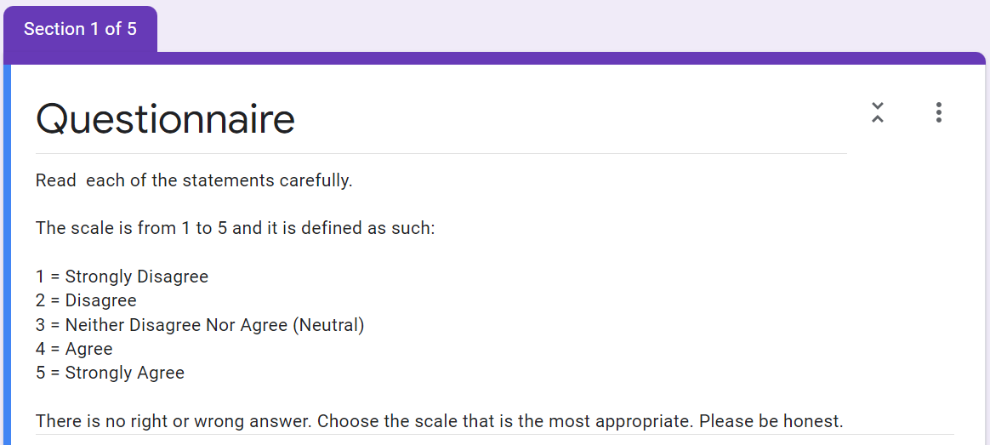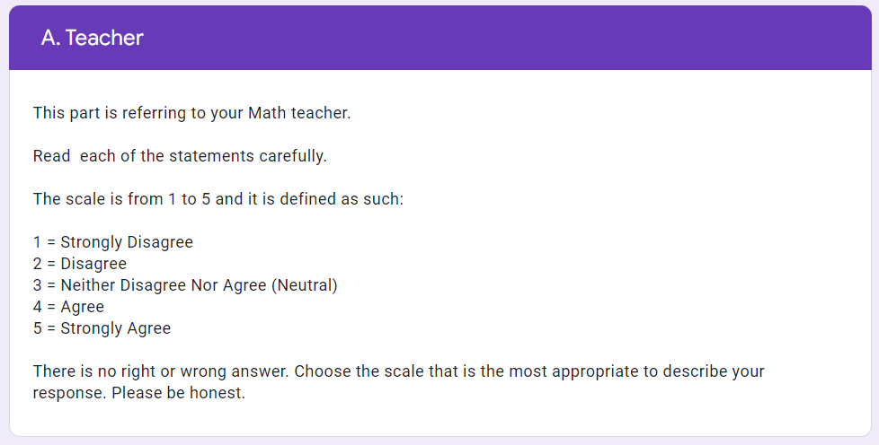

- My teacher shares positive values with her students. *
- My teacher has a loud and clear voice. *
- My teacher is clear in giving instructions. *
- My teacher is fair to her students. *
- My teacher is a role model to her students. *
- My teacher makes it interesting to learn this topic. *
- My teacher encourages students to participate in group work. *
- My teacher has established discipline well. *
- My teacher pushes us to give our best. *
- My teacher promotes collaboration in learning. *
- My teacher is able to answer questions well. *
- My teacher uses technology well in teaching. *
- My teacher uses a variety of teaching techniques. *
- My teacher can relate the topic to real-life applications. *
- My teacher is confident in teaching.
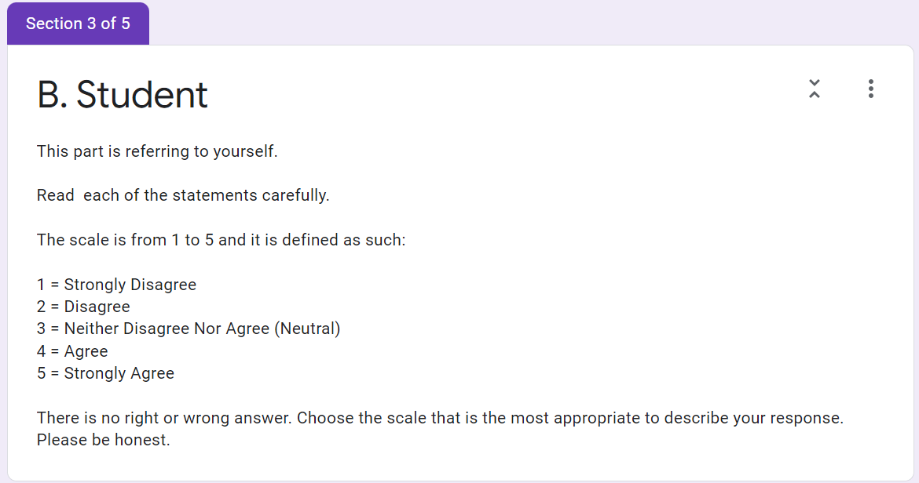

- I enjoy learning even though there is no reward. *
- I prefer classwork that is more challenging. *
- I want to excel in this subject, even though no one asks me to. *
- Even when I did poorly on a test, I try to learn from my mistakes. *
- Getting a good grade in this class is satisfying. *
- It is important for me to improve my overall score. *
- I am more motivated when I am praised for getting a good grade. *
- I want to do well in this class to show my ability to others. *
- I like the topic I am learning right now. *
- It is important for me to learn what is being taught. *
- It is useful for me to learn what is being taught. *
- I will do extra practice to excel in this subject. *
- If I study in a disciplined manner, I will excel in this topic. *
- If I don't understand, it is because I didn't try hard enough. *
- I believe in 'practice makes perfect'. *
- I expect to do better than the others. *
- I am sure I can do an excellent job on the tasks assigned. *
- confident I will receive a good grade in this class. *
- My study methods are excellent. *
- I am not nervous about tests. *

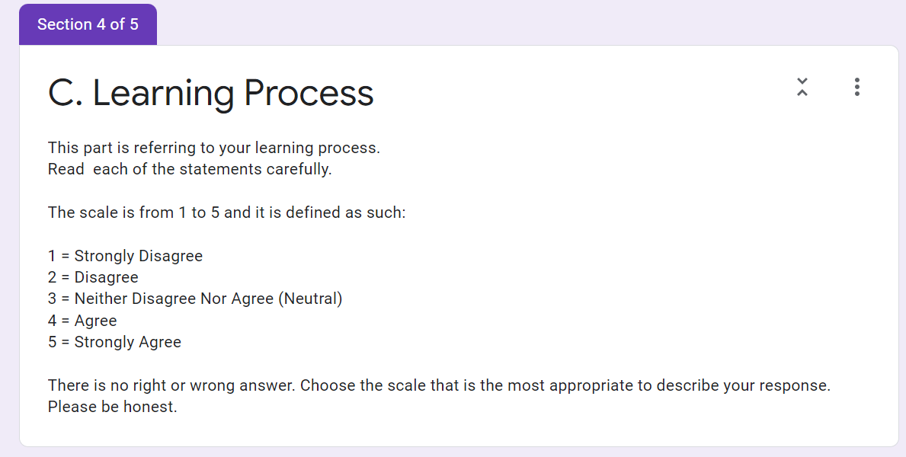
- When I take tests, I do not think of the consequences of failing. *
- I do not have an uneasy feeling when taking a test. *
- During group work, I discuss with my group members to solve the assigned
tasks.*
- The conversations we have during group work are important. *
- My group members will tell and correct others' mistakes. *
- My group members and I are cooperative to collaborate well. *
- During group work, we divide our tasks equally. *
- Working together, we complete the task faster. *
- I enjoy learning together with my group members. *
- I can achieve better results in group work. *
- Group work makes my learning better. *

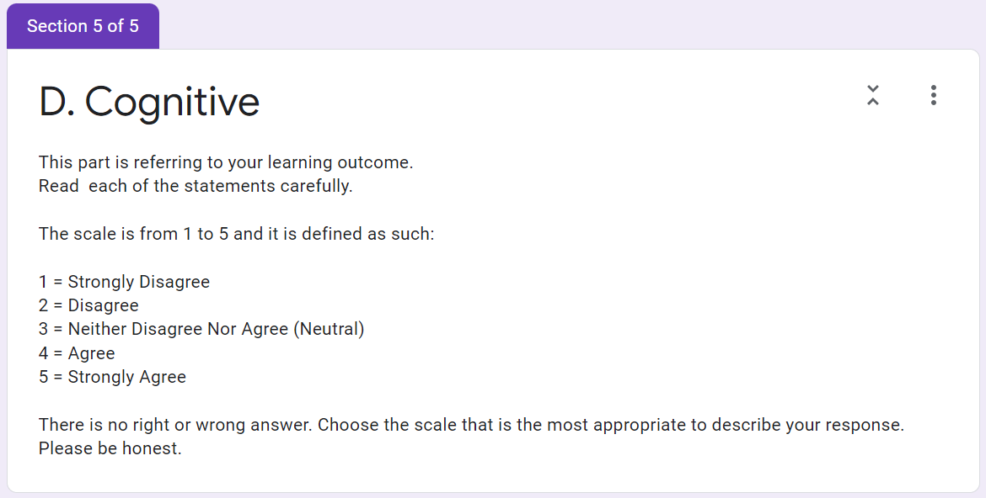
- I remember the formula for finding the circumference of a circle. *
- I remember the formula for finding the area of a circle. *
- I remember the value of pi. *
- I understand the meaning of the keywords/terms learnt in the topic circle:
radius, diameter, circumference, perimeter and area.*
- I understand how Circumference is proportional to Diameter by a constant
called pi.*
- I understand how the formula of the area of a circle came about. *
- I can draw a circle using a compass. *
- I can calculate the area of a circle, given the radius or diameter. *
- I can calculate the circumference of a circle, given the radius or diameter. *

Pilihan ganda Google Form untuk menjawab setiap pernyataan:
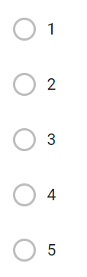

Lampiran B

I. Tabulasi Data Demografis

Nasionalitas
WNA | WNI
5 | 31
14% | 86%

Jenis Kelamin
Laki-laki | Perempuan
22 | 14
61% | 39%

II. Tabulasi Hasil Skoring Variabel Kepemimpinan Guru

Responden | KG1 | KG3 | KG5 | KG12 | KG13 | KG14 | Total | % Skor | Kriteria
1 | 3 | 3 | 3 | 3 | 4 | 2 | 18 | 60% | CB
2 | 3 | 3 | 4 | 5 | 3 | 3 | 21 | 70% | B
3 | 4 | 5 | 3 | 5 | 3 | 4 | 24 | 80% | B
4 | 5 | 3 | 3 | 4 | 3 | 4 | 22 | 73% | B
5 | 4 | 4 | 4 | 2 | 4 | 5 | 23 | 77% | B
6 | 4 | 3 | 2 | 3 | 3 | 3 | 18 | 60% | CB
7 | 5 | 3 | 3 | 4 | 4 | 5 | 24 | 80% | B
8 | 4 | 5 | 4 | 4 | 4 | 5 | 26 | 87% | SB
9 | 4 | 4 | 4 | 4 | 3 | 3 | 22 | 73% | B
10 | 3 | 4 | 3 | 4 | 5 | 4 | 23 | 77% | B
11 | 4 | 5 | 3 | 5 | 4 | 3 | 24 | 80% | B
12 | 3 | 4 | 2 | 3 | 3 | 2 | 17 | 57% | CB
13 | 4 | 4 | 5 | 3 | 3 | 4 | 23 | 77% | B
14 | 3 | 3 | 3 | 2 | 3 | 3 | 17 | 57% | CB
15 | 4 | 4 | 3 | 4 | 3 | 4 | 22 | 73% | B
16 | 5 | 5 | 5 | 5 | 5 | 4 | 29 | 97% | SB
17 | 5 | 5 | 4 | 4 | 5 | 5 | 28 | 93% | SB
18 | 5 | 4 | 4 | 4 | 3 | 4 | 24 | 80% | B
19 | 4 | 5 | 4 | 4 | 4 | 4 | 25 | 83% | B
20 | 4 | 3 | 4 | 5 | 4 | 4 | 24 | 80% | B
21 | 5 | 5 | 5 | 5 | 5 | 5 | 30 | 100% | SB
22 | 5 | 5 | 5 | 5 | 5 | 4 | 29 | 97% | SB
23 | 4 | 4 | 3 | 3 | 2 | 3 | 19 | 63% | CB
24 | 5 | 4 | 3 | 3 | 4 | 4 | 23 | 77% | B
25 | 4 | 4 | 4 | 4 | 3 | 3 | 22 | 73% | B
26 | 5 | 4 | 4 | 5 | 5 | 5 | 28 | 93% | SB
27 | 4 | 4 | 3 | 5 | 3 | 3 | 22 | 73% | B
28 | 4 | 5 | 2 | 4 | 4 | 4 | 23 | 77% | B
29 | 3 | 3 | 2 | 3 | 3 | 2 | 16 | 53% | CB
30 | 2 | 3 | 1 | 2 | 3 | 3 | 14 | 47% | TB
31 | 4 | 4 | 4 | 5 | 4 | 5 | 26 | 87% | SB
32 | 5 | 5 | 5 | 5 | 5 | 5 | 30 | 100% | SB
33 | 3 | 3 | 3 | 3 | 3 | 3 | 18 | 60% | CB
34 | 5 | 4 | 3 | 4 | 5 | 4 | 25 | 83% | B
35 | 4 | 4 | 3 | 4 | 4 | 4 | 23 | 77% | B
36 | 4 | 3 | 4 | 4 | 4 | 3 | 22 | 73% | B
Rata-Rata |  |  |  |  |  |  | 23 | 76% | B

III. Tabulasi Hasil Skoring Variabel Motivasi Siswa

Responden | MS6 | MS11 | MS15 | MS17 | Total | % Skor | Kriteria
1 | 5 | 5 | 4 | 4 | 18 | 90% | SB
2 | 4 | 4 | 3 | 4 | 15 | 75% | B
3 | 3 | 4 | 2 | 2 | 11 | 55% | CB
4 | 3 | 5 | 4 | 3 | 15 | 75% | B
5 | 5 | 5 | 5 | 5 | 20 | 100% | SB
6 | 4 | 4 | 3 | 3 | 14 | 70% | CB
7 | 4 | 5 | 4 | 2 | 15 | 75% | B
8 | 5 | 4 | 5 | 5 | 19 | 95% | SB
9 | 4 | 4 | 4 | 4 | 16 | 80% | B
10 | 3 | 3 | 2 | 2 | 10 | 50% | TB
11 | 5 | 4 | 5 | 4 | 18 | 90% | SB
12 | 3 | 2 | 4 | 3 | 12 | 60% | CB
13 | 4 | 5 | 4 | 4 | 17 | 85% | SB
14 | 3 | 3 | 3 | 3 | 12 | 60% | CB
15 | 5 | 5 | 4 | 3 | 17 | 85% | SB
16 | 4 | 4 | 4 | 4 | 16 | 80% | B
17 | 4 | 4 | 4 | 4 | 16 | 80% | B
18 | 5 | 5 | 5 | 4 | 19 | 95% | SB
19 | 4 | 4 | 3 | 3 | 14 | 70% | B
20 | 5 | 3 | 3 | 5 | 16 | 80% | B
21 | 5 | 5 | 5 | 5 | 20 | 100% | SB
22 | 5 | 5 | 4 | 5 | 19 | 95% | SB
23 | 3 | 2 | 3 | 3 | 11 | 55% | CB
24 | 5 | 4 | 2 | 4 | 15 | 75% | B
25 | 5 | 5 | 5 | 4 | 19 | 95% | SB
26 | 5 | 5 | 5 | 4 | 19 | 95% | SB
27 | 4 | 3 | 2 | 2 | 11 | 55% | CB
28 | 4 | 4 | 4 | 4 | 16 | 80% | B
29 | 3 | 2 | 3 | 2 | 10 | 50% | TB
30 | 3 | 2 | 2 | 4 | 11 | 55% | CB
31 | 5 | 3 | 1 | 4 | 13 | 65% | CB
32 | 5 | 5 | 5 | 5 | 20 | 100% | SB
33 | 3 | 3 | 3 | 3 | 12 | 60% | CB
34 | 5 | 4 | 5 | 4 | 18 | 90% | SB
35 | 3 | 4 | 3 | 3 | 13 | 65% | CB
36 | 4 | 4 | 1 | 3 | 12 | 60% | CB
Rata-Rata |  |  |  |  | 15 | 76% | B

IV. Tabulasi Hasil Skoring Variabel Pembelajaran Kolaboratif

Responden | PK4 | PK5 | PK7 | PK8 | PK9 | Total | % Skor | Kriteria
1 | 2 | 2 | 3 | 3 | 3 | 13 | 52% | CB
2 | 3 | 3 | 2 | 4 | 2 | 14 | 56% | CB
3 | 2 | 2 | 4 | 3 | 2 | 13 | 52% | CB
4 | 4 | 4 | 3 | 4 | 3 | 18 | 72% | B
5 | 4 | 4 | 5 | 5 | 5 | 23 | 92% | SB
6 | 5 | 3 | 4 | 3 | 4 | 19 | 76% | B
7 | 2 | 1 | 4 | 3 | 2 | 12 | 48% | TB
8 | 3 | 3 | 3 | 3 | 3 | 15 | 60% | CB
9 | 4 | 4 | 4 | 3 | 4 | 19 | 76% | B
10 | 3 | 3 | 3 | 2 | 2 | 13 | 52% | CB
11 | 5 | 5 | 5 | 5 | 5 | 25 | 100% | SB
12 | 1 | 1 | 1 | 1 | 1 | 5 | 20% | TB
13 | 3 | 4 | 4 | 4 | 5 | 20 | 80% | B
14 | 3 | 3 | 3 | 3 | 3 | 15 | 60% | CB
15 | 3 | 3 | 4 | 3 | 4 | 17 | 68% | B
16 | 3 | 3 | 3 | 2 | 3 | 14 | 56% | CB
17 | 4 | 5 | 5 | 4 | 5 | 23 | 92% | SB
18 | 5 | 4 | 4 | 5 | 5 | 23 | 92% | SB
19 | 4 | 4 | 3 | 3 | 3 | 17 | 68% | B
20 | 4 | 4 | 3 | 3 | 3 | 17 | 68% | B
21 | 3 | 5 | 4 | 5 | 2 | 19 | 76% | B
22 | 1 | 1 | 1 | 1 | 1 | 5 | 20% | TB
23 | 3 | 1 | 2 | 3 | 2 | 11 | 44% | TB
24 | 3 | 4 | 5 | 5 | 5 | 22 | 88% | SB
25 | 3 | 5 | 5 | 4 | 3 | 20 | 80% | B
26 | 3 | 4 | 5 | 4 | 4 | 20 | 80% | B
27 | 5 | 5 | 4 | 5 | 5 | 24 | 96% | SB
28 | 4 | 4 | 4 | 3 | 3 | 18 | 72% | B
29 | 2 | 3 | 4 | 4 | 3 | 16 | 64% | CB
30 | 1 | 3 | 4 | 5 | 1 | 14 | 56% | CB
31 | 5 | 5 | 5 | 5 | 5 | 25 | 100% | SB
32 | 5 | 5 | 5 | 5 | 5 | 25 | 100% | SB
33 | 3 | 3 | 3 | 3 | 3 | 15 | 60% | CB
34 | 5 | 4 | 4 | 4 | 4 | 21 | 84% | SB
35 | 4 | 3 | 5 | 3 | 3 | 18 | 72% | B
36 | 3 | 4 | 3 | 3 | 3 | 16 | 64% | CB
Rata-Rata |  |  |  |  |  | 17 | 69% | B

V. Tabulasi Hasil Skoring Variabel Kemampuan Kognitif Siswa

Responden | KK1 | KK4 | KK5 | KK6 | KK9 | Total | % Skor | Kriteria
1 | 4 | 3 | 4 | 4 | 4 | 19 | 76% | B
2 | 3 | 4 | 3 | 3 | 3 | 16 | 64% | CB
3 | 4 | 3 | 4 | 5 | 4 | 20 | 80% | B
4 | 4 | 4 | 4 | 5 | 4 | 21 | 84% | SB
5 | 5 | 5 | 5 | 5 | 5 | 25 | 100% | SB
6 | 4 | 4 | 5 | 5 | 4 | 22 | 88% | SB
7 | 4 | 3 | 4 | 1 | 4 | 16 | 64% | B
8 | 5 | 5 | 5 | 5 | 5 | 25 | 100% | SB
9 | 4 | 4 | 4 | 4 | 4 | 20 | 80% | B
10 | 4 | 3 | 3 | 3 | 3 | 16 | 64% | CB
11 | 5 | 5 | 5 | 5 | 5 | 25 | 100% | SB
12 | 5 | 5 | 5 | 4 | 5 | 24 | 96% | SB
13 | 4 | 4 | 4 | 3 | 3 | 18 | 72% | B
14 | 4 | 3 | 3 | 3 | 3 | 16 | 64% | CB
15 | 5 | 5 | 5 | 3 | 5 | 23 | 92% | SB
16 | 5 | 4 | 4 | 4 | 5 | 22 | 88% | SB
17 | 3 | 4 | 2 | 3 | 4 | 16 | 64% | CB
18 | 3 | 5 | 4 | 5 | 4 | 21 | 84% | SB
19 | 5 | 4 | 4 | 4 | 4 | 21 | 84% | SB
20 | 5 | 5 | 5 | 5 | 5 | 25 | 100% | SB
21 | 5 | 5 | 5 | 5 | 5 | 25 | 100% | SB
22 | 5 | 5 | 5 | 5 | 5 | 25 | 100% | SB
23 | 4 | 4 | 3 | 4 | 4 | 19 | 76% | B
24 | 5 | 5 | 5 | 5 | 5 | 25 | 100% | SB
25 | 4 | 4 | 3 | 5 | 4 | 20 | 80% | B
26 | 3 | 5 | 5 | 4 | 4 | 21 | 84% | SB
27 | 5 | 5 | 4 | 5 | 4 | 23 | 92% | SB
28 | 4 | 5 | 5 | 4 | 5 | 23 | 92% | SB
29 | 2 | 3 | 2 | 3 | 3 | 13 | 52% | CB
30 | 3 | 4 | 3 | 3 | 4 | 17 | 68% | CB
31 | 5 | 5 | 5 | 5 | 4 | 24 | 96% | SB
32 | 5 | 5 | 5 | 5 | 5 | 25 | 100% | SB
33 | 3 | 3 | 3 | 3 | 3 | 15 | 60% | CB
34 | 5 | 5 | 5 | 5 | 5 | 25 | 100% | SB
35 | 4 | 5 | 3 | 3 | 4 | 19 | 76% | B
36 | 4 | 4 | 5 | 5 | 5 | 23 | 92% | SB
Rata-Rata |  |  |  |  |  | 21 | 84% | SB

LAMPIRAN C

I. Cross Loading

Variabel | Kepemimpinan Guru | Motivasi Siswa | Pembelajaran Kolaboratif | Kemampuan Kognitif Siswa
KG1 | 0,836 | 0,555 | 0,361 | 0,487
KG3 | 0,733 | 0,385 | 0,179 | 0,472
KG5 | 0,741 | 0,613 | 0,227 | 0,290
KG12 | 0,708 | 0,314 | 0,191 | 0,363
KG13 | 0,739 | 0,482 | 0,162 | 0,361
KG14 | 0,805 | 0,489 | 0,364 | 0,348
MS6 | 0,568 | 0,917 | 0,454 | 0,663
MS11 | 0,580 | 0,735 | 0,285 | 0,294
MS15 | 0,391 | 0,700 | 0,154 | 0,276
MS17 | 0,458 | 0,840 | 0,249 | 0,559
PK4 | 0,327 | 0,269 | 0,844 | 0,321
PK5 | 0,361 | 0,383 | 0,899 | 0,271
PK7 | 0,266 | 0,280 | 0,810 | 0,083
PK8 | 0,109 | 0,294 | 0,790 | 0,110
PK9 | 0,292 | 0,388 | 0,898 | 0,254
KK1 | 0,441 | 0,387 | 0,104 | 0,807
KK4 | 0,480 | 0,580 | 0,392 | 0,839
KK5 | 0,416 | 0,563 | 0,163 | 0,889
KK6 | 0,332 | 0,437 | 0,358 | 0,741
KK9 | 0,483 | 0,551 | 0,091 | 0,896

II. Overview of Average Variance Extracted (AVE), Composite Reliability, R Square, Cronbach’s Alpha

Variabel | Average Variance Extracted (AVE) | Composite Reliability | R Square | Cronbach's Alpha
Kepemimpinan Guru | 0,580 | 0,892 |  | 0,855
Motivasi Siswa | 0,644 | 0,877 |  | 0,823
Pembelajaran Kolaboratif | 0,722 | 0,928 | 0,164 | 0,905
Kemampuan Kognitif Siswa | 0,699 | 0,920 | 0,405 | 0,892

III. Model Uji Validitas Konvergen

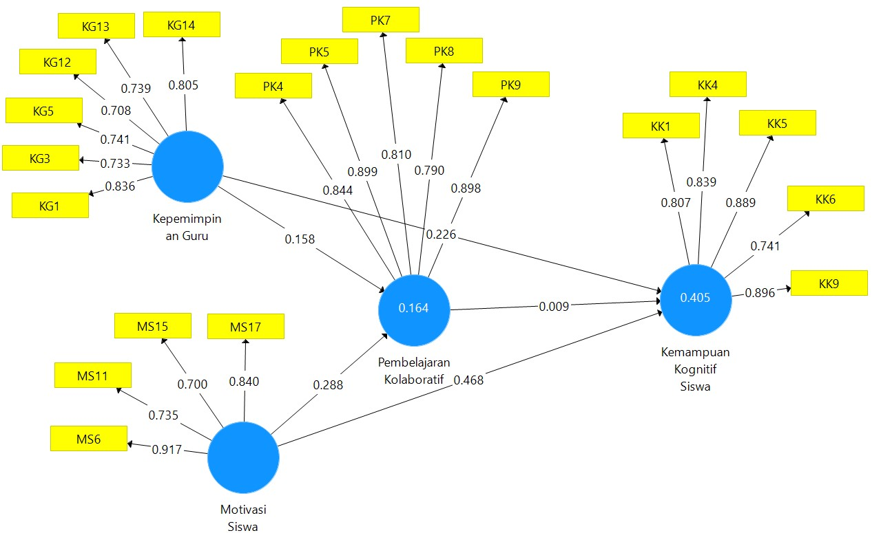

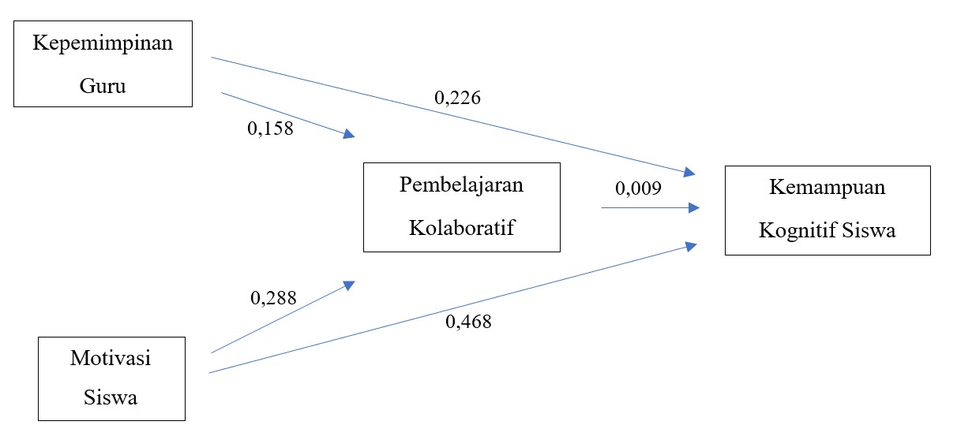
IV. Model Uji Koefisien Jalur

