**LAMPIRAN**

**Lampiran 1. Releksi Mengajar 3 Agustus 2021**

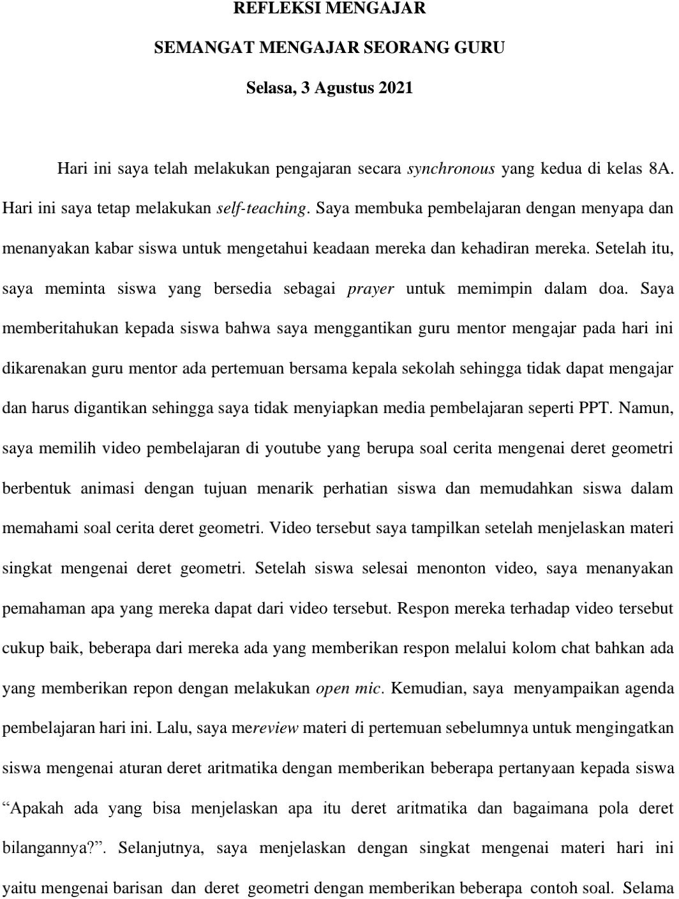

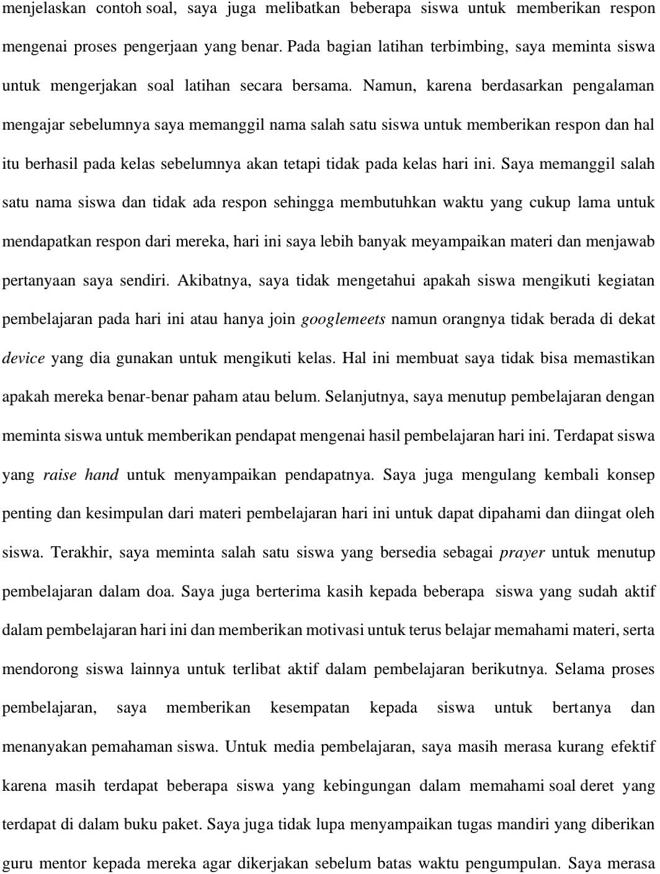

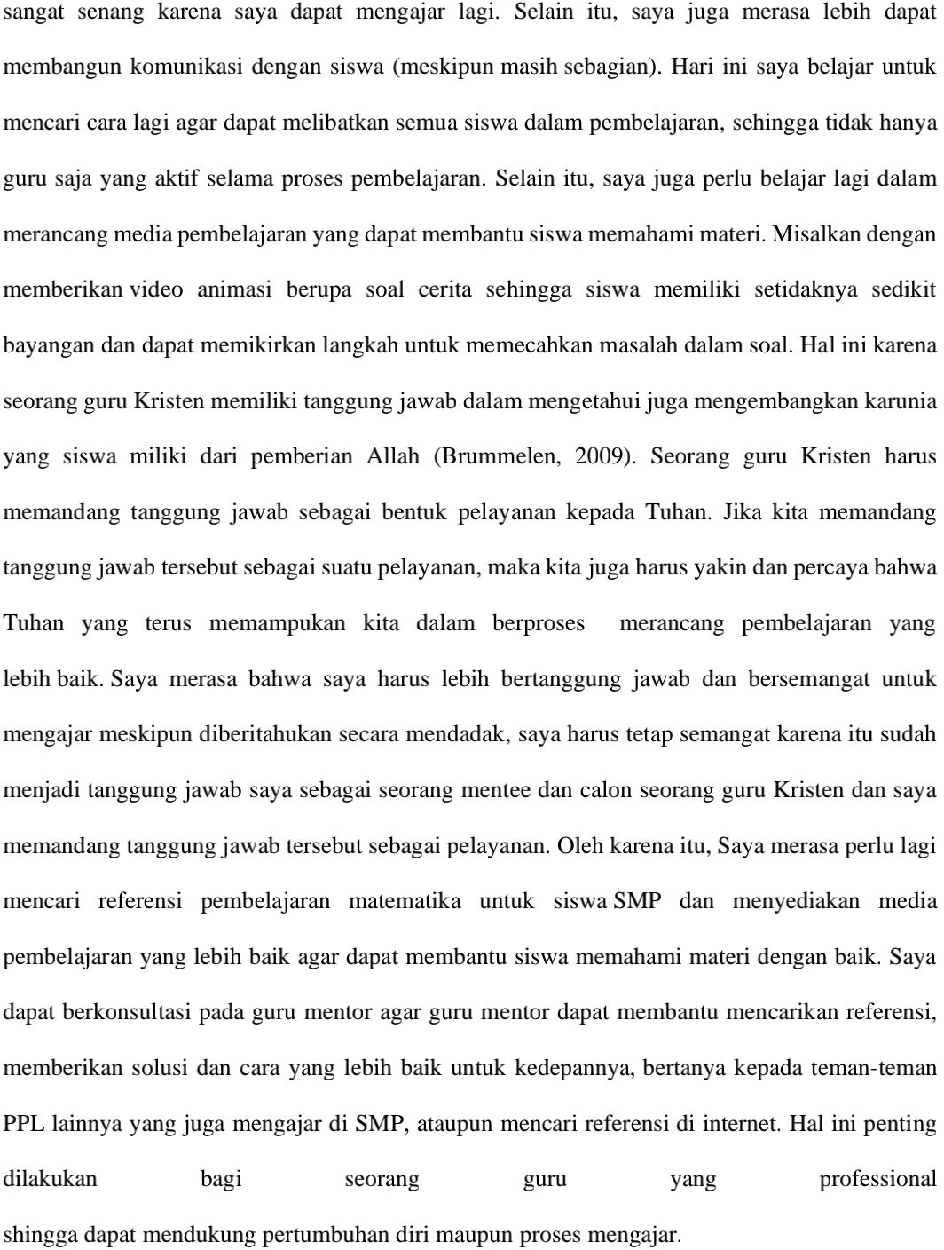

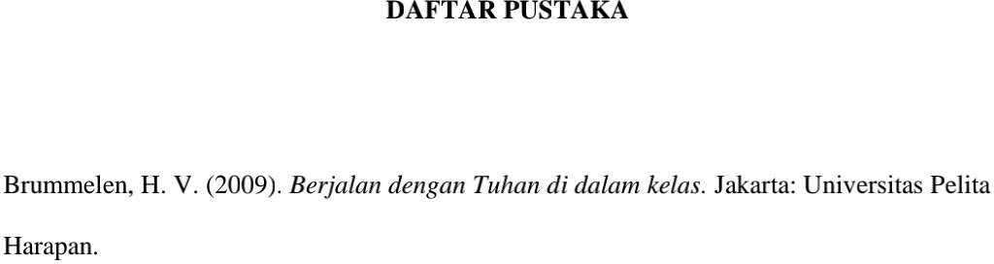

**Lampiran 2. Refleksi Profesionalitas**

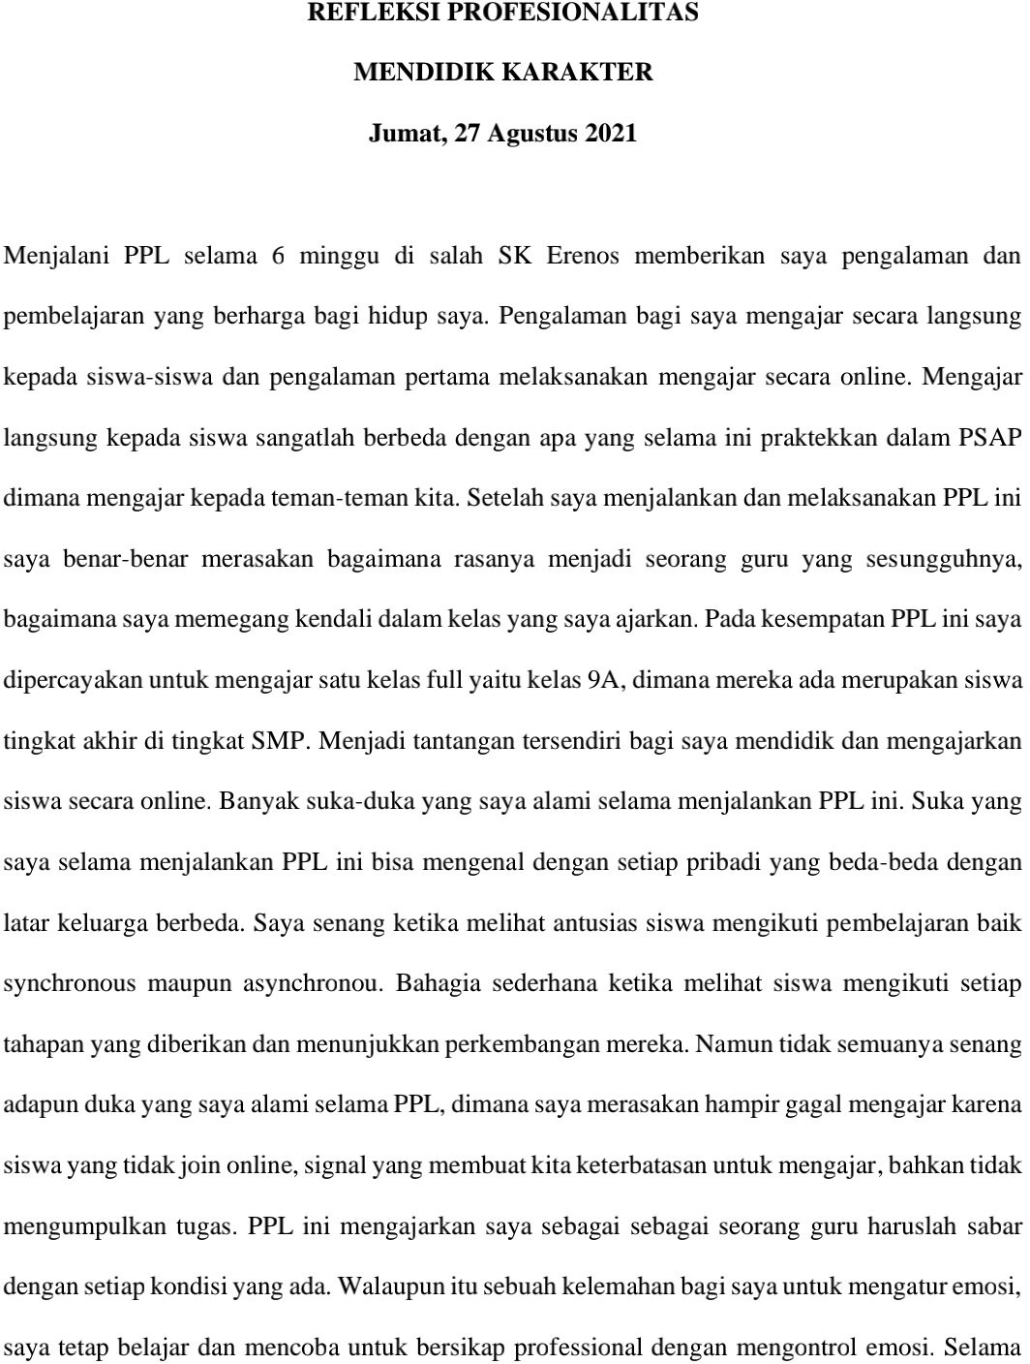

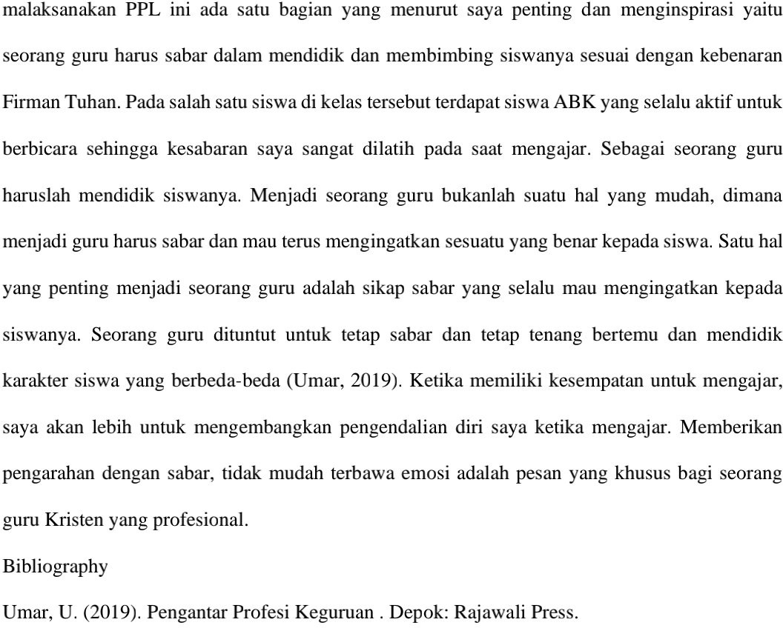

**Lampiran 3. Form Umpan Balik Mentor 2 Agustus 2021**

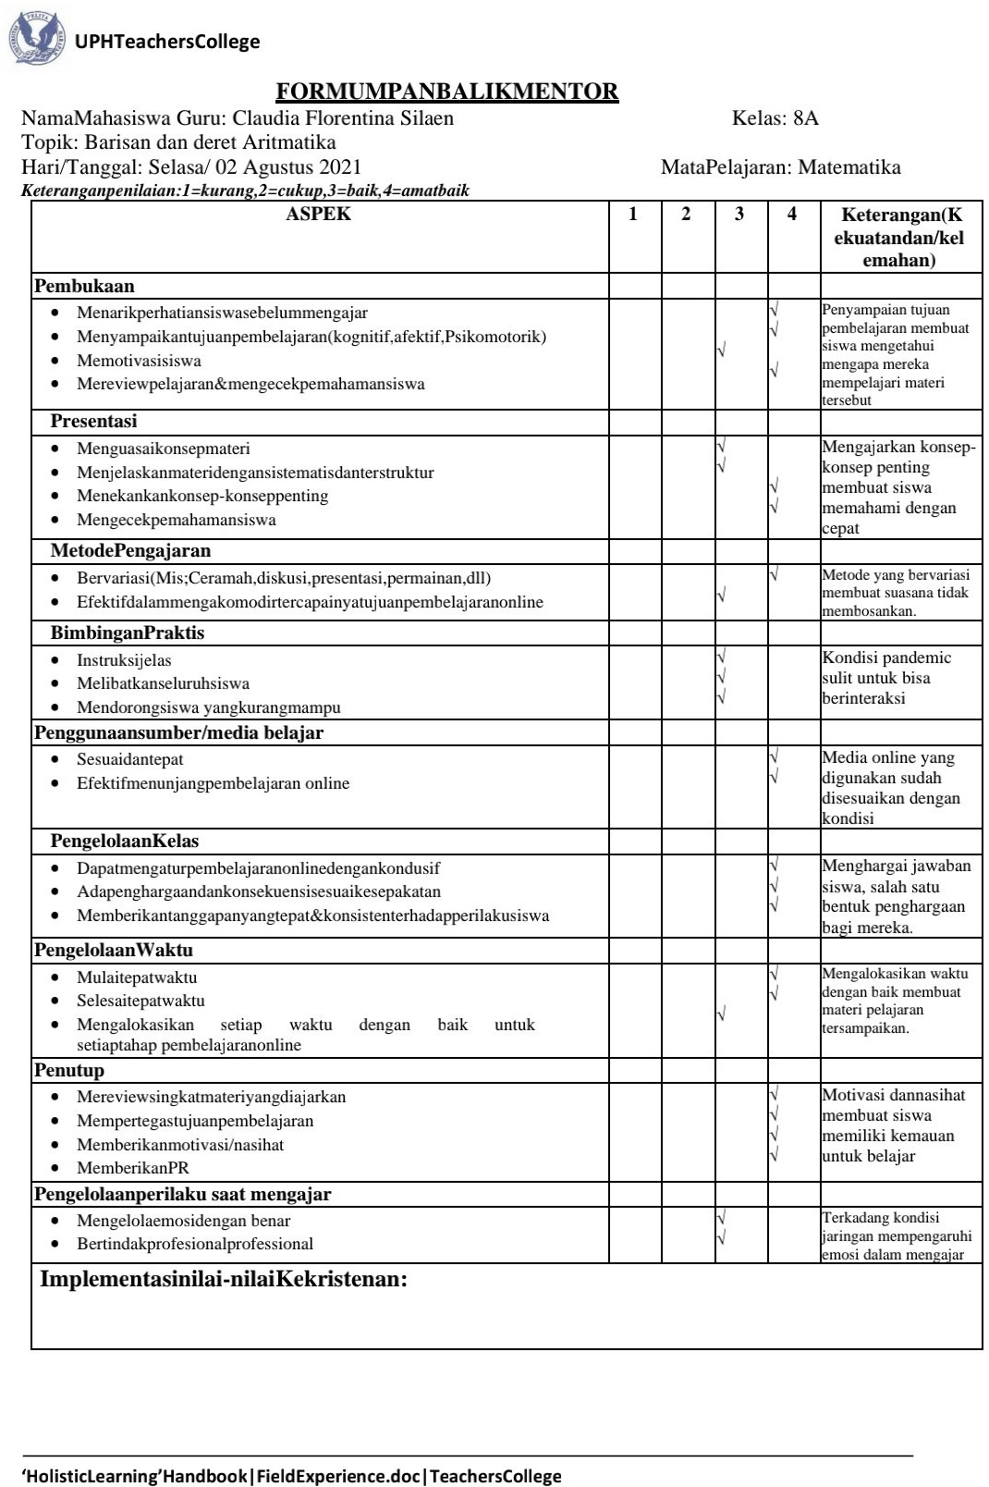

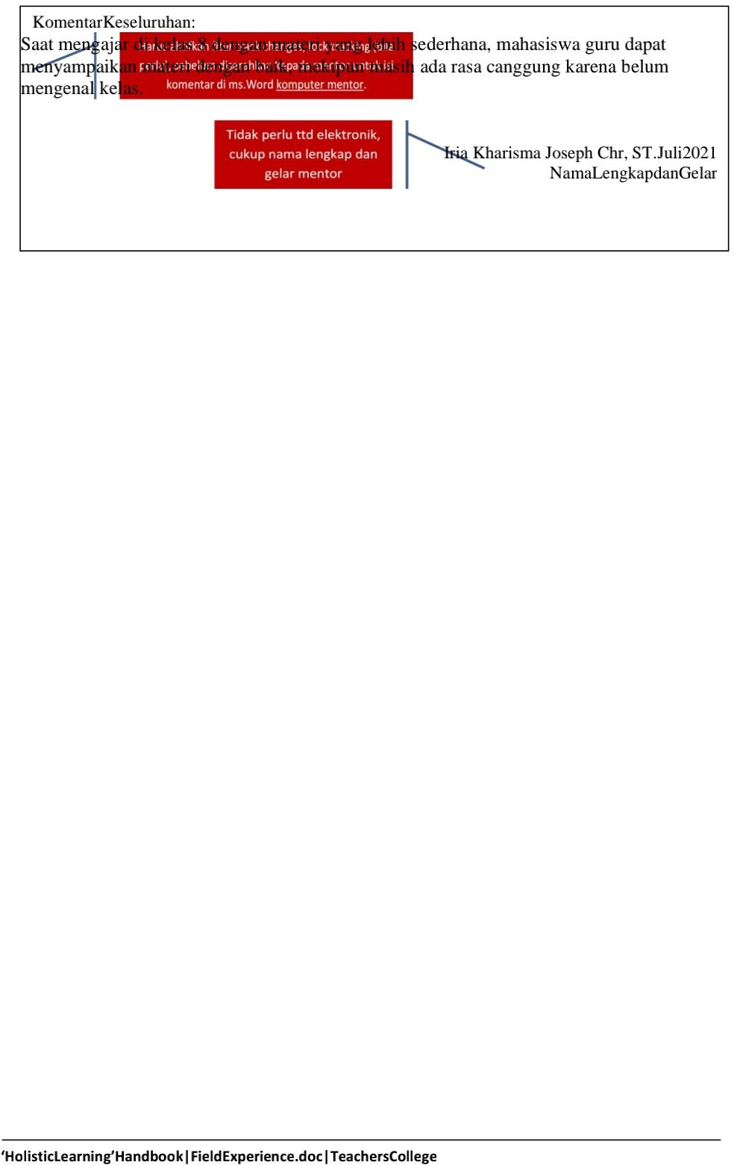

**Lampiran 4. Form Umpan Balik Mentor 25 Agustus 2021**

