Testing MKTOR in Tanzania Universities

Dau, Ramadhani, K.*¹

Yussuf, Huda, A.²

Senior Lecturer in Marketing, Muslim University of Morogoro¹

Lecturer in Economics, Muslim University of Morogoro²

Email: ramadau@gmail.com

Abstract

This paper seeks to examine the relationship between market orientation (MO) and university performance (UP) in universities in Tanzania. Data were collected from 212 private and public universities across the country. MKTOR was used to measure the degree of MO and how it is related to performance. Data were analyzed with the help of SPSS and AMOS 22. Reliability and validity tests show the measures were within acceptable boundaries.

A positive and significant relationship was found between MO and UP. Contrary to a widely held belief, the results show MKTOR has two dimensions namely, customer and competitor orientations and the former had the strongest influence on UP. The study makes an important contribution by being the first of its kind that is pan territorial (drawing its sample from both public and private universities) that provides empirical evidence of the relationship between MO and UP in Tanzania and indeed in Africa.

Post Covid 19, universities should be prepared to be financially sustainable as resources from Governments will be addressed to more pressing health needs. They should address evolving student needs taking into account their career development beyond university days. Governments should support universities both, private and public by providing tax breaks to companies that support ground breaking research whose findings could be commercialized.

The study is cross sectional and did not consider mediating variables. A longitudinal study would be more appropriate to explain if the observed relationships are true over a period of time.

Keywords Market orientation, MKTOR, Performance, Tanzania, University.
Table 1 Profile of respondents

 |  | no. | Percentage
Position | Junior Staff | 80 | 37.7%
 | Senior Staff/Head of Departments | 117 | 55.2%
 | Professors/Deans/Directors | 15 | 7.1%
Gender | Male | 149 | 70.3%
 | Female | 63 | 29.7%
Age | Below 25 years | 1 | 0.5%
 | 25-45 years | 145 | 68.4%
 | Above 45 years | 66 | 31.1%
Qualifications | PhD | 113 | 53.3%
 | Master degree | 85 | 40.1%
 | Bachelor degree | 14 | 6.6%
Experience | Less 10 years | 87 | 41.1%
 | 10-20 years | 98 | 46.2%
 | More than 20 years | 27 | 12.7%
Ownership | Public Universities | 153 | 72.2%
 | Private Universities | 59 | 27.8%
Size | Less 5000 students | 72 | 34%
 | 5000-10000 students | 50 | 23%
 | More than 10000 students | 90 | 42%

Table 2 Exploratory Factor Analysis (independent variables)
Rotated Component Matrix a
Component

1 2

CUS1 .174 .737
CUS2 .377 .762
CUS3 .297 .780
CUS4 .287 .775
CUS5 .418 .703
CUS6 .443 .689
CUS7 .736 .421
COM1 .753 .410
COM2 .722 .340
COM3 .802 .324
COM4 .770 .246
COM5 .675 .353
COM6 .727 .356
IFC1 .730 .268
IFC2 .765 .273
IFC3 .317 .643
IFC4 .399 .603

Extraction Method: Principal Component Analysis. Rotation Method: Varimax with Kaiser Normalization. Rotation converged in 3 iterations. KMO .949. Variance explained 64.95%.

Table 3 Exploratory Factor Analysis (dependent variables)

Rotated Component Matrix a
Component

1 2 3

P1 .802 .068 .320
P2 .861 .191 .100
P3 .474 .746 .053
P4 .009 .859 .276
P5 .101 .441 .761
P6 .293 .058 .874

KMO .745 variance explained 79.5%

Table 4 Reliability

Factor
Variable/Items Loadings AVE Alpha CR DV

Performance

P1 .802
P2 .861 .570 .706 .724 .755

P3 .746
P4 .859 .531 .662 .686 .728

P5 .761
P6 .874 .572 .723 .958 .756

Customer

CUST1 .737
CUST2 .762
CUST3 .780
CUST4 .775
CUST5 .703
CUST6 .689
IFC3 .643
IFC4 .603 .572 .913 .914 .756

Competition

COMP1 .753
COMP2 .722
COMP3 .802
COMP4 .770
COMP5 .675
COMP6 .727
CUS7 .736
IFC1 .730
IFC2 .765 .622 .936 .937 .789

P1 and P2 = Retain; P3 and P4 = Satisfy; P5 and P6 = Growth; Cust = customer orientation
Comp= competitor orientation; DV= discriminant value, i.e., square root of AVE; CR=composite reliability

Table 5 Discriminant validity test

 | CUSTOMER | COMPETE | RETAIN | SATISFY | GROWTH
CUSTOMER | .756 | .821 | .317 | .577 | .576
COMPETE |  | .789 | .253 | .385 | .482
RETAIN |  |  | .755 | .560 | .632
SATISFY |  |  |  | .728 | .666
GROWTH |  |  |  |  | .756

Figures in diagonal represent Cronbach alpha. The rest are correlations among
latent variables

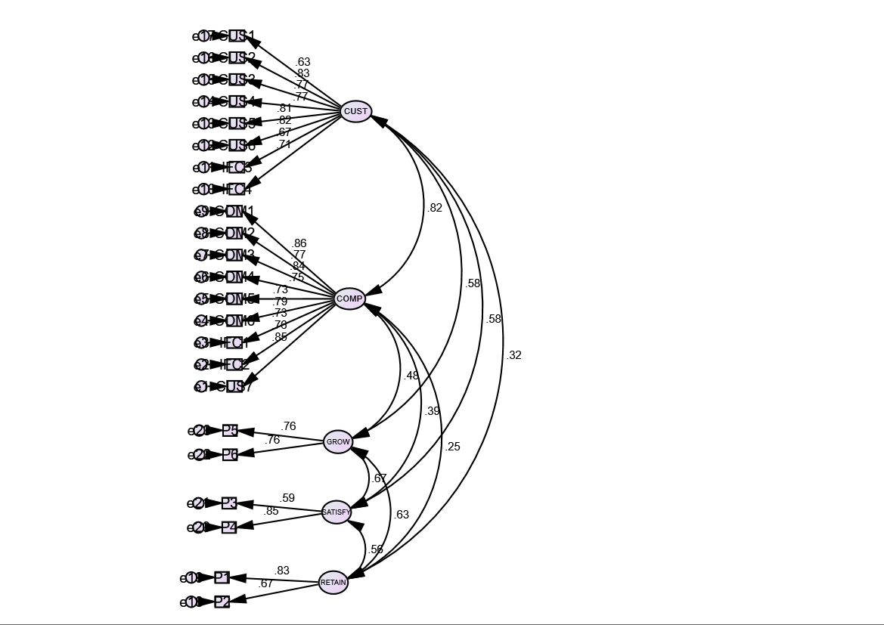 Fig 1 Measurement model

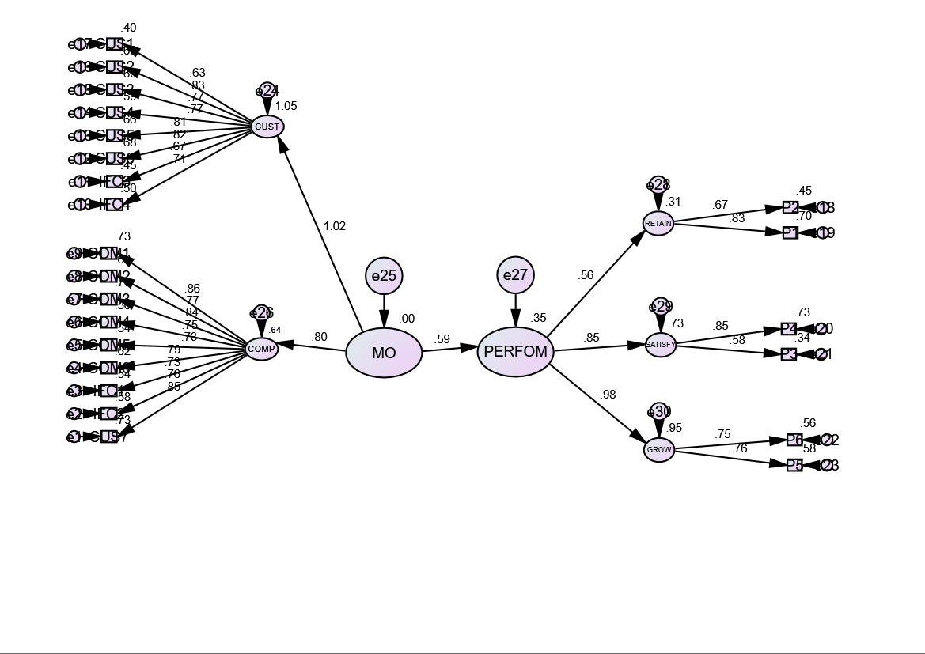
Fig 2 Structure Model

