Innovativeness

Pro-activeness

EO1

**H2**

Risk Taking

SEO3

BP5

**H1 H3**

SO2

CA4

**Gambar 1. Kerangka konseptual**

*1Entrepreneurship Orientation (EO), 2Sustainability Orientation (SO), 3Sustainable Entrepreneurial Orientation (SEO), 4Competitive Advantage (CA), 5Business Performance (BP)*

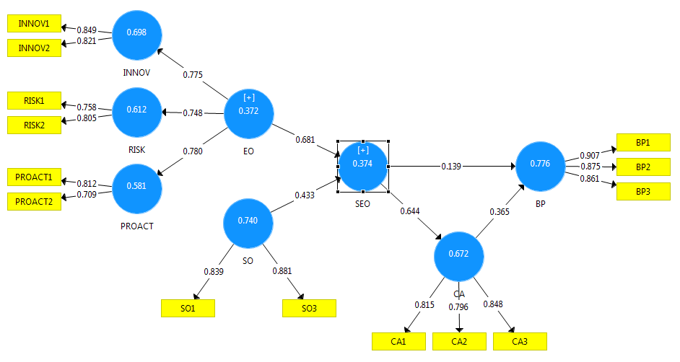

**Gambar 2. Uji model pengukuran *first-order***

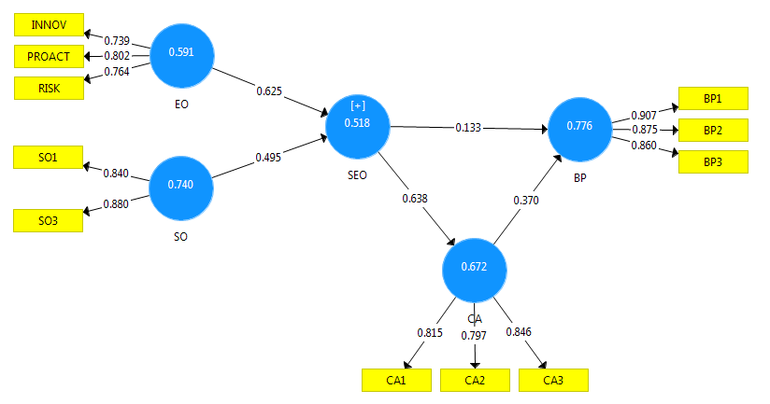

**Gambar 3. Uji model pengukuran *second-order***

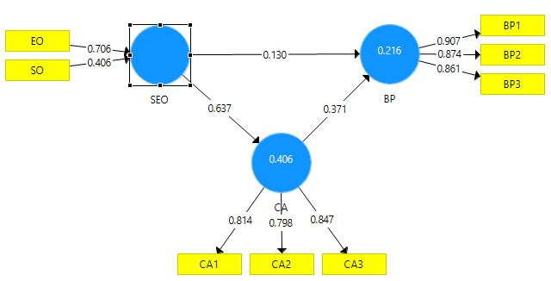

**Gambar 4. Uji model pengukuran *third-order***