HOW VIETNAMESE ORGANIZATIONS PERCEIVE THE USE OF SOCIAL MEDIA IN CRISIS COMMUNICATION

Tuong-Minh Ly-Le

Bond University, Queensland, Australia

e-mail: tuong-minh.ly-le@student.bond.edu.au

ABSTRACT

Social media has proliferated into everyday life of Vietnamese people. As a result, in the past years, Vietnam has seen many organizational crises that started on this platform. Social media has proven to be able to foster crises, thanks to open platforms that allow for relatively free discussion among strangers with common interests.
Nonetheless, Vietnamese organizations have often ignored or underutilized these channels in their crisis communication efforts. Organizations prioritize using traditional media in their crisis communication efforts and paid little to no attention to social media outlets, even if the crisis had started on social media channels.
Through a survey with experienced Vietnamese PR practitioners, this research aims to understand this trend of crisis management and explore the perception of Vietnamese organizations toward the use of social media in crisis communication.

Keywords: social media adoption, crisis communication, crisis response, Vietnam

1. Introduction
More than 48 percent of the country’s population can be found on social media, with even higher percentages among younger demographics with whom it has become the most popular means of communication (Kemp, 2017). As a result of its proliferation into everyday life of Vietnamese people, it makes sense that more business crises are spreading there. Social media has proven itself more than capable of fostering crises, thanks to open platforms that allow for relatively free discussion among strangers with common interests. Easy sharing, powerful influencers, and the tendency of negative posts to gather attention have led to numerous stories which began on social media to become viral and escalate into full-on crises.

Despite its prevalence, Vietnamese companies generally fail to fully take advantage of social media in crisis response, preferring traditional media outlets such as press releases and press conferences, even when the crisis is born on social media. The public relations field in Vietnam has historically focused on marketing and reputation management, neglecting crisis response. (Van, 2013). This study is intended to focus on the underreported topic of how organizations use social media during a crisis, and why so many still do not.

2. Literature Review
Differences of opinion on the trustworthiness of social media are not new. Study results have differed on whether social media is as credible as traditional media (as supported by Austin, Liu & Jin, 2012 and Procopio & Procopio, 2007) or less credible (as in Richter, 2014). The Vietnamese Ministry of Information and Communication’s Media Department has stated that Vietnamese people now trust social media more than traditional media, but cited no studies leading to this conclusion (Bao Dien Tu DCSVN, 2012).
In 2017, Vietnam had an estimated 46 million social media users among its population of 93 million, a number that has surely grown considering that the country is listed among the fastest for digital growth (Kemp, 2017).
Studies have found that social media is useful for offering stakeholders a convenient channel to communicate with organizations during a crisis (e.g. Ruehl & Ingenhoff, 2015). They emphasize its ability to keep stakeholders up to date and offer community and support (e.g. Austin et al., 2012; Procopio & Procopio, 2007).
Nonetheless, in the author’s review of published media articles on previous crises from 2010-2015, social media received little attention from Vietnamese organizations and traditional media was always a preferred communication platform Van’s (2013) research on PR in Vietnam also found that Vietnamese organizations have preferred using traditional media during crises.

2.1. Social media is a useful tool for crisis communication.
Organizations can use social media tools during a crisis to update stakeholders, keep them in the loop, and work together to find a satisfactory solution (Ulmer, Sellnow & Seeger, 2015). Speed, ease of access, and a personal communication are the most recognized advantages of social media. Schultz, Utz and Glocka (2012), in their review of the existing literature, iterate these as its key advantages. Taking advantage of these aspects can make organizations appear more caring, concerned and committed, improving its reputation during and after a crisis (Sweetser & Metzgar, 2007; Kerkhof, Beugels, Utz & Beukeboom, 2011).
Crisis communication literature and practice tends to emphasize the importance of a quick response to meet the needs of stakeholders and media. A too-slow response tends to lead to speculation, rumor, and critical voices dominating the conversation, hampering the vital task of controlling the narrative. For these reasons, social media’s near-instant communication makes it an appealing medium (McLean & Power, 2009; Coombs, 2014).
Social media allows organizations to enter the conversation and create a response that can be easily shared by members of the target audience. Stronger, earlier participation on social media creates improves the organization’s crisis communication options (Jaques, 2014).

2.2. Downsides of social media.
In Vietnam, Van’s (2013) research found that companies with previous crises used very little social media to communicate and concluded that traditional media is a preferred platform for crisis communication. Further, a recent research on crisis communication in Vietnam concluded that while a crisis response on social media can lead to better perception of an organization, it does not lead to any supporting action or cease to talk badly about an organization (Ly-Le, 2018). In brief, social media is not highly regarded by both Vietnamese organizations and stakeholders.
Examining the characteristics of social media in more depth, studies found that despite its many strengths, social media has some weaknesses to watch out for. Some literature showed that in general communication, social media has many disadvantages, such as being uncontrollable, and having limited reach (e.g. Jacques, 2014; Coombs, 2014). More specifically, in crisis communication, its main disadvantages are speed, visibility, and limited reach.
The speed that makes social media so useful for spreading a message also allows crises to escalate – and end – faster than other forms of media. Stakeholders can use it to spread critical comments and negative content as fast or faster than the organization’s intended message (Coombs, 2014). For organizations, the price of using social media is the need for vigilance to protect their reputations.
Another disadvantage of social media is the constant exposure of an organization to the public in the online world. Even when a crisis seems to be over, information and responses to it tend to linger on social media platforms, waiting to be linked to a new crisis and inflamed again. It is not only difficult to remove the information that began a crisis, it is unwise to do so. Stakeholders expect crisis management to be as public as the crisis itself, and to provide information on what organizations do to address complaints and other warning signs. (Coombs, 2014). Continued neglect of warning signs that are visible to stakeholders can build into a crisis of its own.

3. Research Design
This research used a survey to discover factors that encourage and discourage organizations in Vietnam from using social media to communicate during a crisis. It used both open-ended questions with write-in answers, and closed-ended questions based on a five-point Likert scale (“strongly disagree,” “disagree,” “neither disagree nor agree,” “agree,” and “strongly agree”). It was distributed online to PR practitioners who have at least two years of experience in the Vietnamese PR industry. It also used the paired Wilcoxon test to examine differences in the results for social media and traditional media.
The survey used the snowball sampling method to recruit suitable experts from among PR practitioners in the country’s PR hubs of Ho Chi Minh and Ha Noi. Early respondents were encouraged pass on the survey to qualified acquaintances, until the survey had 50 respondents. These consisted of PR practitioners ranging in age from 22 to 46 (mean: 28, standard deviation: 5.3). The respondents were 36.0% male (N=18) and 64.0% female (N=32). The respondents were a mix of agency and in-house practitioners with a wide range of experience levels.

4. Results
4.1. Organizations in Vietnam use social media as frequently as traditional media channels to communicate with stakeholders during crises.
The first set of questions asked respondents how often their organizations used traditional media (media conferences and media releases) to communicate about crises and how often their organizations used social media to communicate.
Figure 1 presents the frequencies of organizations’ use of each platform for crisis communication purposes. The overall results indicate very similar choices of traditional media and social media for crisis communication across all respondents’ organizations. 82% answered that their organization uses traditional media in crisis communication at least some of the time, and 72% answered that their organization uses social media at least some of the time. Although there were some differences in using traditional media and social media in crisis communication, the differences were statistically insignificant (p = 0.661).
The results were used to further analyzed any differences between the perceptions of agency practitioners and in-house practitioners. Figure 2 compares the use of traditional media among agency versus in-house respondents, and figure 3 compares the use of social media among these respondents.
The results between agency and in-house respondents were quite similar in their use of traditional media for crisis communication.77.8% of agency respondents and 84.4% of in-house respondents answered that their organizations at least occasionally use traditional media for this purpose. Nonetheless, agency respondents showed a greater commitment than in-house respondents to using traditional media. 44.4% of agency respondents answered that their organizations always use media conferences and releases (traditional media tools) in crisis communication, while the most frequent answer of in-house respondents was that their organizations occasionally use this platform (50%).
Figure 3 presents that agencies use social media more frequently (77.8% had used) than their in-house counterparts (68.8%). While 55.6% of agency respondents mentioned that they always use social media in crisis communication, only 31.3% of in-house respondents answered that they always use it. Noticeably, 31.3% of in-house respondents answered that their organizations never use social media in crisis communication activities.

4.2. Organizations in Vietnam perceive that social media is less useful than traditional media in crisis response.
The objective of the next set of questions was to compare the performance expectancy of social media to that of traditional media with three characteristics: ease of communication, speed and cost-effectiveness, and compare the usefulness of traditional media and social media.
Figure 4 below presents organizations’ perception of social media’s performance expectancies through three aforementioned characteristics. The results show that respondents were mostly in favor of social media’s performance. Communication on social media is considered easy (68.0% at least agreed), fast (82.0% agreed) and cost-effective (58.0% agreed). Overall, the survey showed that social media is expected to perform as well as traditional media in terms of ease of communication, speed and cost-effectiveness.
Figures 5 through 7 present the levels of agreement to each expectancy among agency versus in-house respondents.
Overall, a cross-category analysis showed that while respondents from both agency and in-house groups had high performance expectation of social media, the agency respondents did not think as highly of social media’s performance expectancy as their in-house counterparts in all three examined dimensions.

4.3. Vietnamese organizations tend to choose crisis communication platforms based on the characteristics of each crisis.
Going into more depth regarding the use of media for crisis communication, the next questions aimed to see if PR practitioners had preferred communication channels (traditional media or social media) during crises, or if the channels were chosen case-by-case.
Figure 8 presents the levels of agreement on organizations’ overall preference of crisis communication channels. Respondents indicated that Vietnamese organizations choose channels based on the characteristics of each crisis (88% at least agreed), rather than having fixed channels for all crises (76% agreed). The difference was statistically significant (p = 0.009).
Figure 9 presents the levels of agreement that an organization has preferred channels for crisis communication among agency versus in-house respondents. Figure 10 shows the levels of agreement that an organization chooses channels for crisis communication based on characteristics of each crisis. Both figures indicate that when assessing whether their organizations choose crisis communication channels from a preferred selection or based on each crisis, agency and in-house respondents had similar opinions. A slightly higher percentage of agency respondents said that they have preferred channels than in-house respondents (83.3% and 71.9% respectively), while there were comparable percentages of respondents in each category who choose the channels on a case basis (88.8% and 87.5% respectively).
The author then turned to compare preferences across the two workplace groups. Among agency respondents, 83.3% at least agreed that they have preferred channels, which is slightly lower than the 88.8% at least agreed that they choose the crisis communication channels on a case-by-case basis. Nevertheless, the percentage of agency respondents who strongly agreed that they have preferred channels was half of the percentage of respondents who strongly agreed about making a case-by-case choice (22.2% and 44.4% respectively). The difference was statistically significant (p = 0.034).
The in-house results show that more in-house respondents chose the crisis communication channels on a case basis (87.5%) than on a fixed preference (71.9%). However, the difference here was not statistically significant (p = 0.060).

4.4. Social media should be used together with traditional media in crisis communication.
The survey respondents were provided an open-ended portion to address their perceptions about social media use in crisis communication in more details.
The survey respondents stated that depending on the nature of the involved organization, the scale of a crisis and the demographics of the key stakeholders and involved groups, social media or traditional media should be chosen as the main channel for communication:
We need to analyze a crisis carefully to decide on a suitable communication channel. For example, my target customers are farmers with limited use of social media, so I have to use traditional media to reach them. – An in-house practitioner with two to five years of experience.
Social media is an important crisis communication channel… However, I think it depends on the nature of the organization and the crisis to decide. I work for a state company and [our crisis communication procedure] only uses one spokesperson and limited response on social media. We use traditional media to respond and to build the relationship with the media at the same time. – An in-house practitioner with six to eight years of experience.
The open-ended answers included the main crisis characteristic that influences the use of each platform in crisis communication. There were three main responses: the origin of a crisis (on which platform it started), the stakeholders of a crisis (people who are affected or care about a crisis, not necessarily the key stakeholders of the responsible organization in normal times) and the need for an immediate reply. The respondents generally agreed that if a crisis starts on social media, the involved groups are younger people and the crisis scope is small, social media can be used for crisis response. For crises on a larger scale or for negative news that is spreading too fast, traditional media was said to be the main channel for communication.
It depends on the crisis. If a crisis starts on social media, I’ll use social media to respond and reach out to the involved stakeholders [on social media] to negotiate or stop the negative comments. – An in-house practitioner with two to five years of experience.
If a crisis starts on social media and has not had big impact yet, we can use social media to respond. We don’t want to publicize the issue to a bigger public [by responding on another platform, in this case, traditional media]. However, if a crisis is escalating fast, traditional media is the main platform to offer official response and action. – An agency practitioner with two to five years of experience.
Nonetheless, in both cases, the survey respondent indicated that social media should be used together with traditional to increase the efficiency.
Crisis communication needs a thorough approach. While social media and traditional media don’t have an apparent advantage compared to the other, it’s better to combine their strengths for better coverage and more complete reach to the stakeholders. – An in-house practitioner with six to eight years of experience.

5. Discussion
Comparing social media and traditional The survey results showed that organizations in Vietnam use social media channels as frequently as traditional media to communicate with stakeholders during crises. While the integration of social media in crisis communication can be expected from the reviewed studies on the emergence of social media in crisis communication, it is a surprising finding about the practice in Vietnam, as the preliminary research did not observe a frequent use of social media in crisis communication by Vietnamese organizations. The finding that social media is used as frequently as traditional media in crisis communication may indicate that Vietnamese organizations have gradually noticed the benefits of this platform. Another possible reason is that not all PR practitioners surveyed in this study had encountered a crisis. Practitioners reported that social media was mentioned in their organization’s crisis communication plan or used more in the precrisis stage, rather than during the crisis response. Thus, the results could show an intention to use social media during crises, not an actual use.
The survey results found that public relations practitioners in Vietnam generally think social media is as useful in crisis response and performs as well as traditional media. This finding was unexpected. This may indicate that social media is still diffusing in Vietnam and its advantages are being more recognized among Vietnamese organizations.
Besides, the survey results indicated that Vietnamese organizations consider the preference of their stakeholders and the characteristics of each crisis to pick appropriate communication channels. A combination of traditional media and social media use in crisis response was also believed to strengthen a crisis response. This practice is in line with the perception of stakeholders about social media, as study found that stakeholders consider information on social media as not trustworthy and show few supportive reactions to organizations responding on this platform. A combined use of social media and traditional media in crisis communication could be a mutual expectation of Vietnamese organizations and stakeholders. This practice should be continued in future crisis communication activities.

5. Conclusion
This study suggests that although social media is not as appreciated by Vietnamese organizations as traditional media, it is still used as frequently in crisis communication efforts, and is expected to be combined with traditional media. The diffusion of social media in organizational crisis communication may be still ongoing and social media is anticipated to be used more in actual crisis responses, not just in plans or during precrisis phase.

APPENDIX
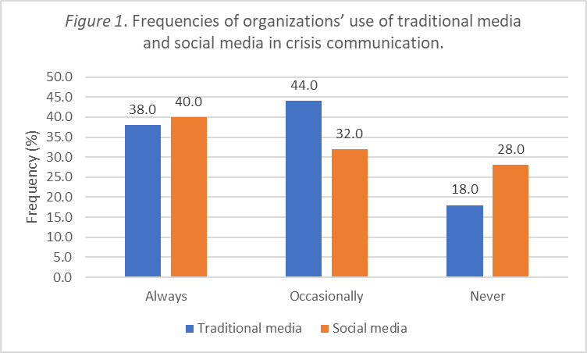

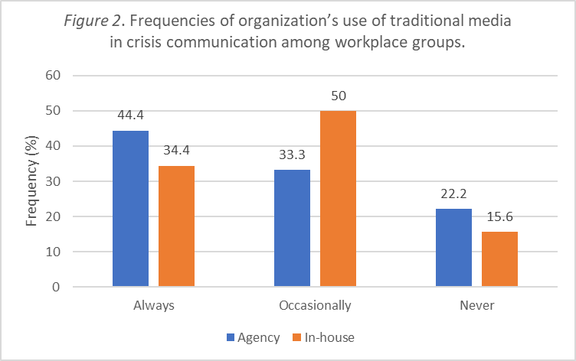

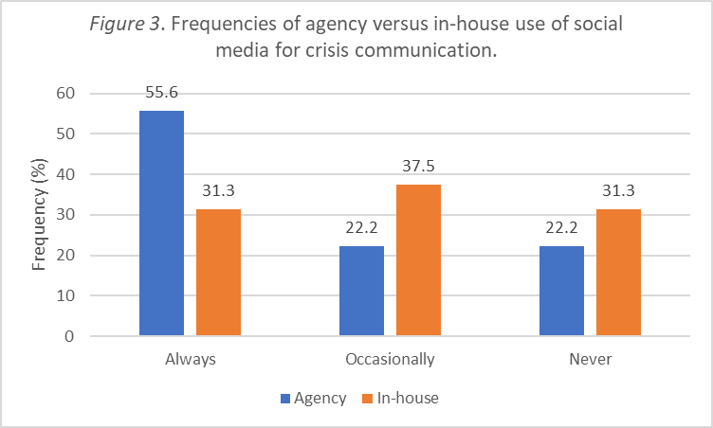

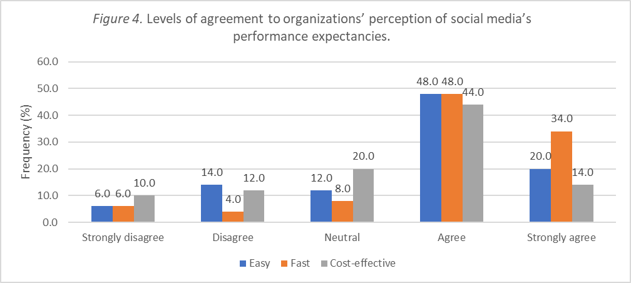

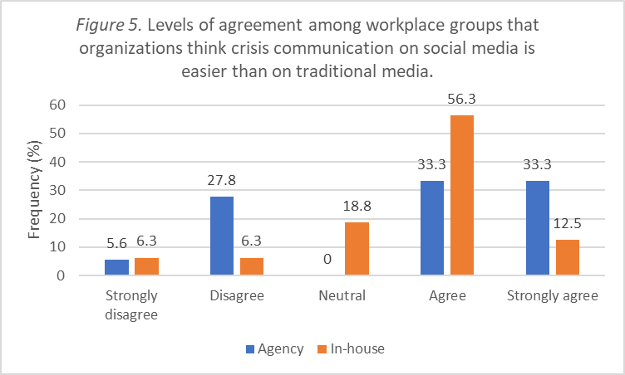

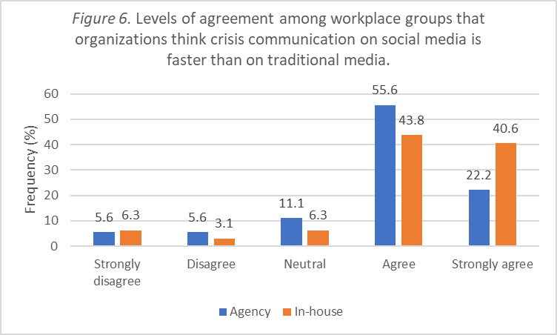

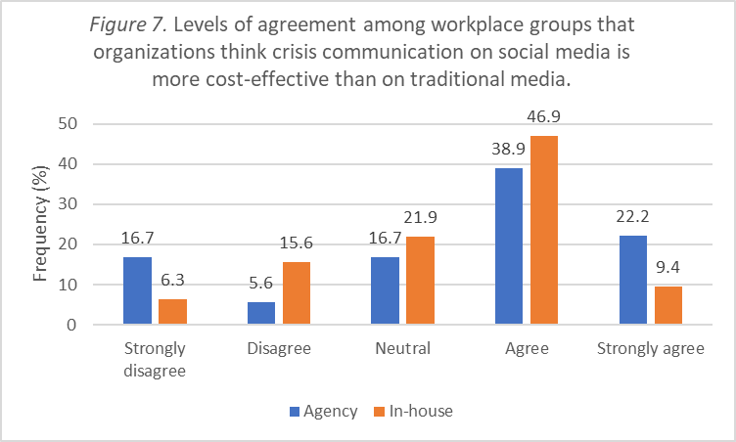

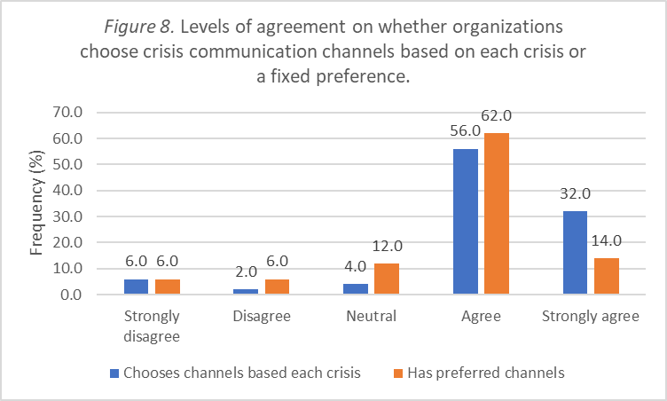

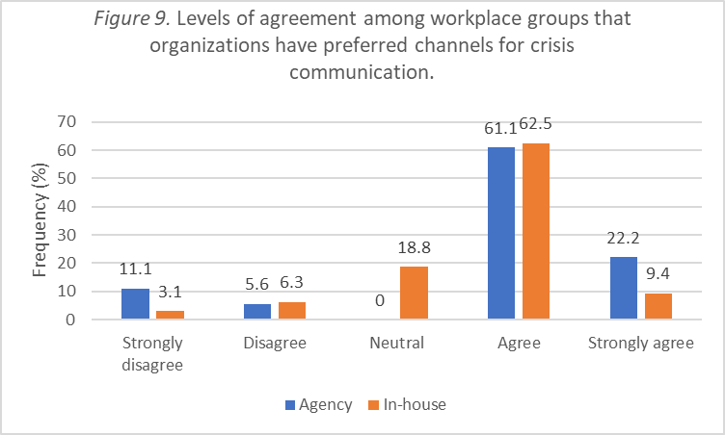

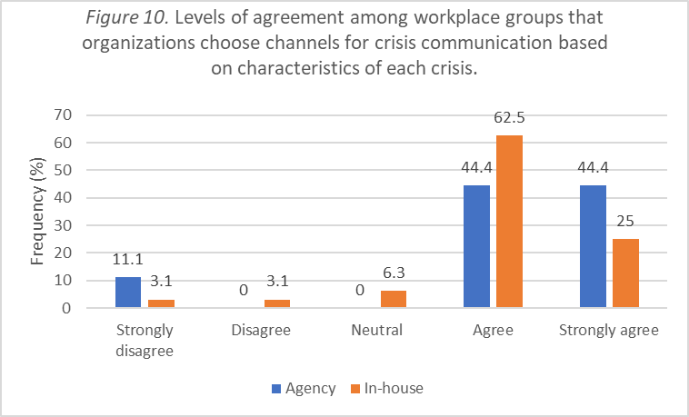

REFERENCES
Austin, L., Liu, B. F., & Jin, Y. (2012). How audiences seek out crisis information: Exploring the social- mediated crisis communication model. Journal of Applied Communication Research, 40(2), 188-207.
Bao Dien Tu DCSVN. (2012, June 7). Media and social media. Ha Noi Moi. Retrieved from http://hanoimoi.com.vn/Tin-tuc/Chinh-tri/549777/bao-chi-va-su-dung-mang-xa-hoi
Coombs, W. T. (2014). Ongoing crisis communication: Planning, managing and responding. (4th ed.). Thousand Oaks, CA: Sage.
Jaques, T. (2014). Issue and crisis management: Exploring issues, crises, risk and reputation. Victoria, Australia: Oxford.
Kemp, S. (2017, February 16). Digital in Southeast Asia in 2017. Retrieved from https://wearesocial.com/uk/special-reports/digital-southeast-asia-2017
Kerkhof, P., Beugels, D., Utz, S., & Beukeboom, C. (2011a, May). Crisis PR in social media: An experimental study of the effects of organizational crisis responses on Facebook. Paper presented at The 61st annual ICA conference, Boston.
Ly-Le, T. M. (2018). Social media use in crisis communication in Vietnam: A stakeholder’s viewpoint. Proceedings of the Fifth International Conference on Business, Management and Accounting (IBSM 2018), 259-274.
McLean, H., & Power, M. (2009). Crisis command: Strategies for managing corporate crises. London: Ark Group.
Procopio, C. H., & Procopio, S. T. (2007). Do you know what it means to miss New Orleans?: Internet communication, geographic community, and social capital in crisis. Journal of Applied Communication Research, 35(1), 67-87.
Richter, F. (2014, March 28). 30% of U.S. adults get news on Facebook. Retrieved from http://www.statista.com/chart/2069/news-consumption-on-social-networks/
Ruehl, C. H., & Ingenhoff, D. (2015). Communication management on social networking sites: Stakeholder motives and usage types of corporate Facebook, Twitter and YouTube pages. Journal of Communication Management, 19(3), 288-302.
Schultz, F., Utz, S., & Glocka, S. (2012). Towards a networked crisis communication theory: Analyzing the effects of (social) media, media credibility, crisis type, and emotions. In Proceedings of the International Communication Association. Phoenix: All Academics.
Sweetser, K. D., & Metzgar, E. (2007). Communicating during crisis: Use of blogs as a relationship management tool. Public Relations Review, 33(3), 340-342.
Ulmer, R., Sellnow, T., & Seeger, M. (2015). Effective crisis communication: Moving from crisis to opportunity. (3rd ed.). London: Sage.
Van, L. T. H. (2013). Contemporary public relations in Vietnam: Public relations challenges in a culturally different setting (PhD thesis).

